Flight Reservation System
Aim
To develop a simple cloud-based Flight Reservation System that allows users to view flight details and make bookings using a SaaS platform.
Algorithm
- Start
- Create flight reservation form
- Enter user details (name, flight, date)
- Store booking information in cloud database
- Display available flights
- Allow user to select and reserve a flight
- Save booking details
- Stop
Procedure
- Open Zoho Creator
- Create a new application named Flight Reservation System
- Create a form called Flight_Booking
- Add the following fields:
  - Booking_ID (Auto Number)
  - Passenger_Name (Single Line)
  - Source (Dropdown: Chennai, Delhi, Mumbai)
  - Destination (Dropdown: Chennai, Delhi, Mumbai)
  - Travel_Date (Date)
  - Number_of_Seats (Number)
  - Total_Price (Currency)
- Save the form
- Create a report to view bookings
- Enter sample data and test the system
- Deploy the application to cloud
Output
- User can enter booking details
- Flight reservation data is stored in cloud
- Bookings can be viewed and managed easily
- System provides simple reservation functionality
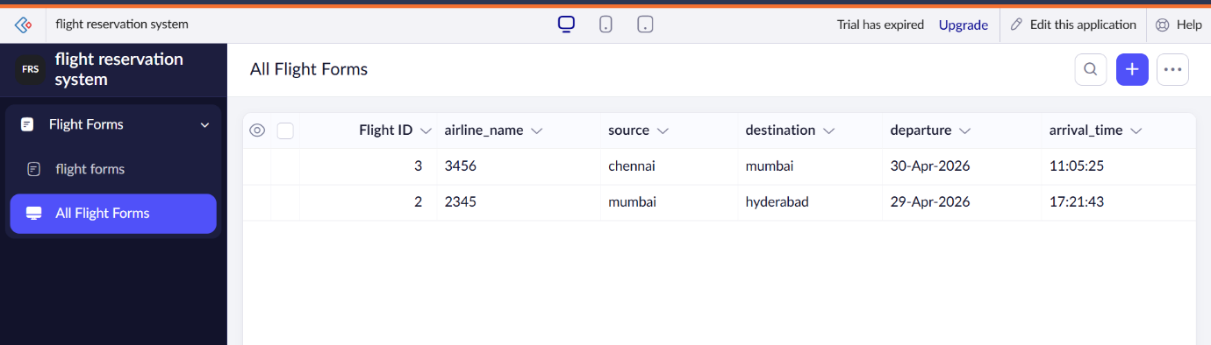
Result
A simple cloud-based Flight Reservation System was successfully developed using Zoho Creator. The system allows users to reserve flights online and demonstrates the SaaS model through browser-based access and centralized data management.

